9/5/2025

Report on Student Performance Analysis

Petridis Dimitrios, student of study program “Data Science and Machine Learning”

TABLE OF CONTENTS

Pages 2-4:
Introduction, Data Description, Data Cleaning

Pages 5-7:
Exploratory Data Analysis (EDA)

Pages 7-8:
Predictive Modeling

Page 9:
Student Clustering

Page 10:
Results and Insights, Conclusion and Recommendations

Introduction
This report is based on a presentation that analyzed student grades to predict exam performance and identify patterns among students, with the goal of providing recommendations for improving student success.
Data Description
- The dataset includes student performance data from 159 students.
- Types of activities included in the data are Exams, Homework (4 assignments), Compulsory Activities (8), and Optional Activities (10).
- Grades are recorded as numeric values from 0-10, or -1 for non-participation.
- Grades are chronologically ordered.
Data Cleaning
- Special analysis was conducted for students who did not participate in the final exams. Below the distribution histograms for the specific students’ performance on Assignments, Compulsory Activities and Optional Activities are given
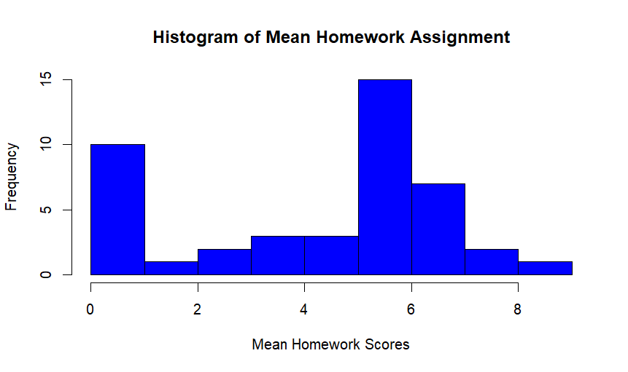
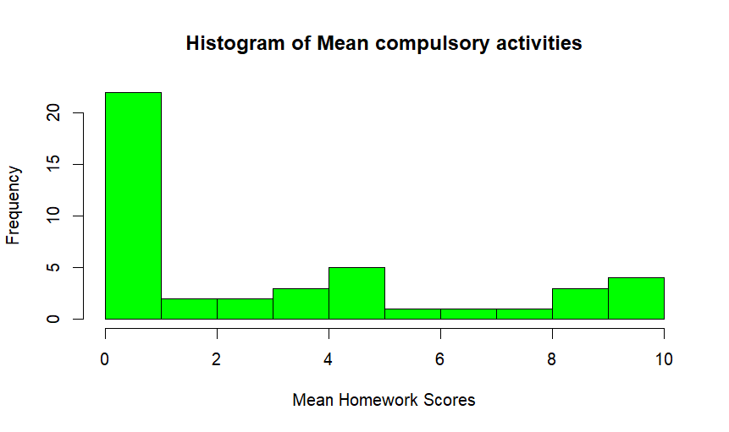
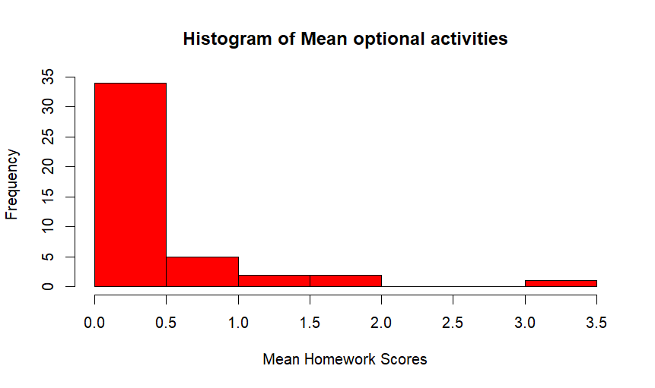
- Afterwards, missing values, representing non-participation, were handled by excluding or imputing the data. 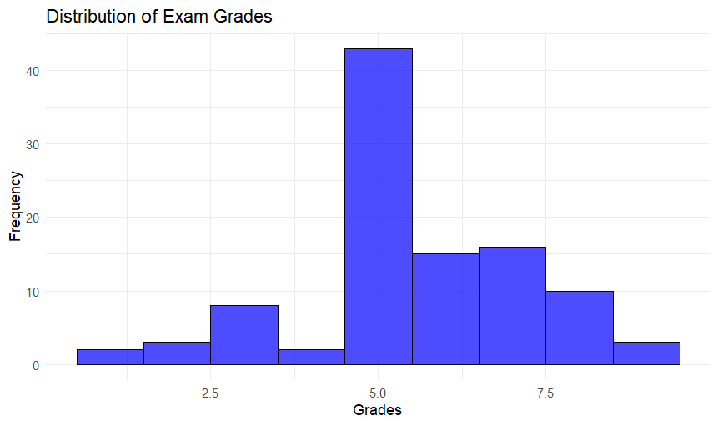

- Outliers were identified and removed. They are seen on the boxplot below
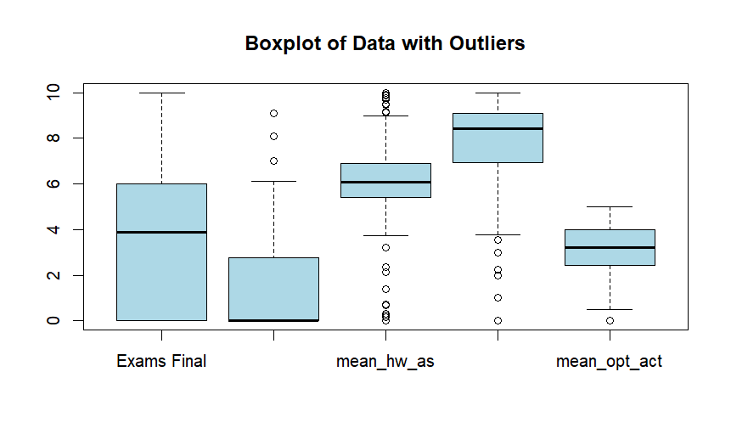
- Outcomes were labeled for predictions, including pass/fail and grade categories (good, very good, excellent).
Exploratory Data Analysis (EDA)
- Grade distribution analysis was performed. The distribution of the final grades and the grades pie of participating studets is given below
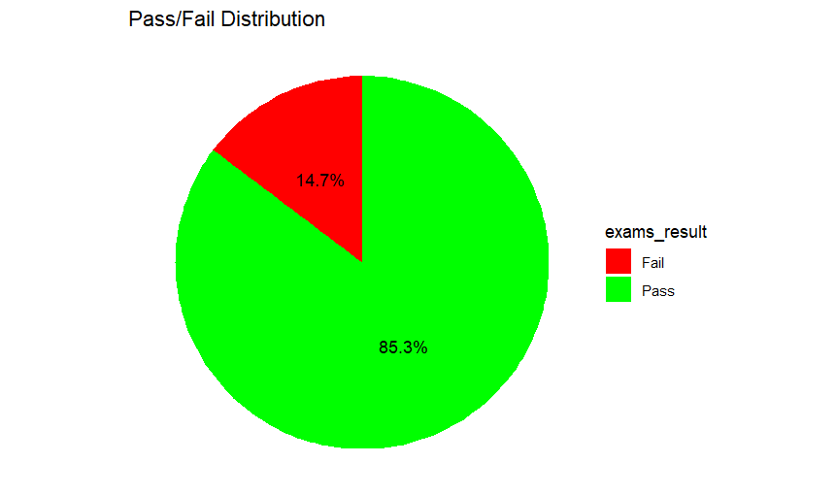

- Principal Component Analysis (PCA) was used to determine the significance order of variables. The variances for the Principal components are presented on the matrix below
PC1 | PC2 | PC3 | PC4 | PC5
0.449 | 0.257 | 0.133 | 0.097 | 0.065
The matrix indicates that the first 2 Components have the most significance but this is not very strong. For visualization a scree plot is provided
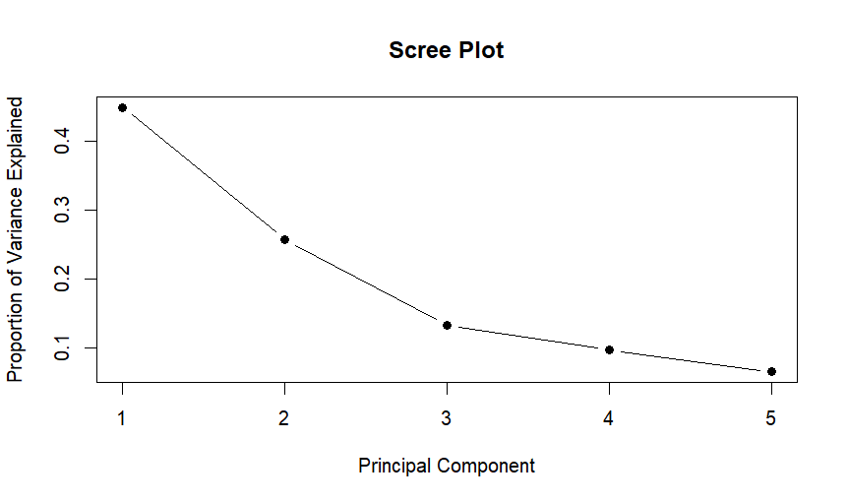
- Covariance analysis showed a positive relationship between final grades and Homework, Compulsory Activities, and Optional Activities, suggesting that higher assignment scores are associated with higher final grades. The covariance matrix explains the previous comments
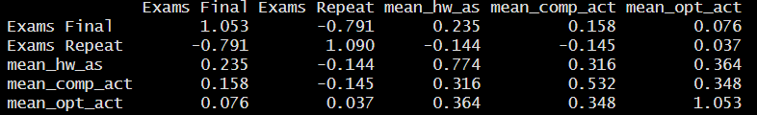

- Correlations between final grades and assignment scores were positive but not very strong (0.38 with Assignments, 0.15 with Compulsory activities, and 0.42 with Optional Activities), indicating a weak to moderate positive relationship. Here is the corresponding Heatmap

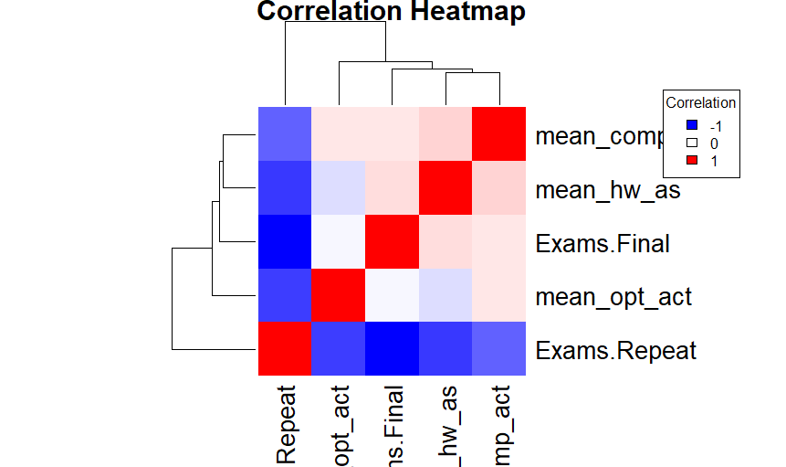

Predictive Modeling
- The following steps were taken for prediction:
- Data preprocessing, including scaling and standardizing.
- Linear Regression Models (single and multiple) were used for exam prediction. The slope and the intercept of the single lineal model are shown in the plot below
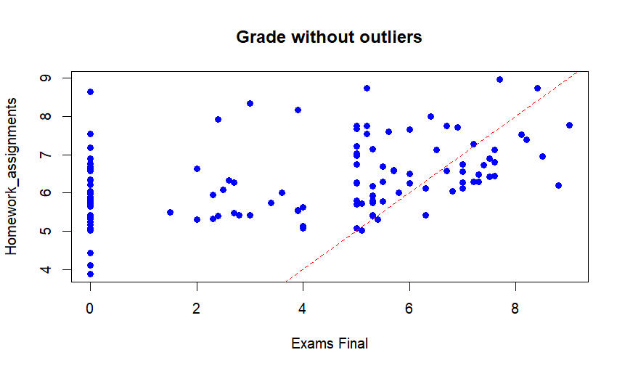
- Support Vector Machines were also used for exam prediction with the following results of passing the exams
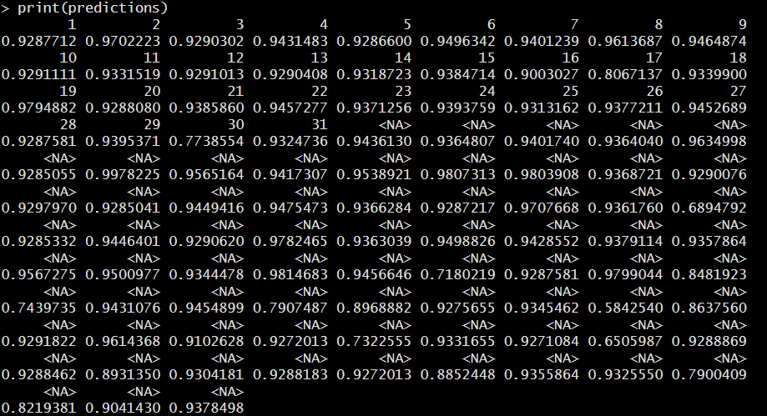

- Hypothesis testing and Naive Bayes were conducted. Here are the Naïve bayes results
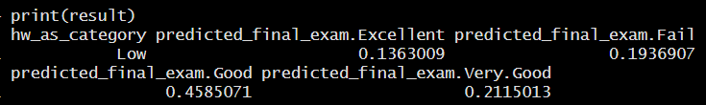
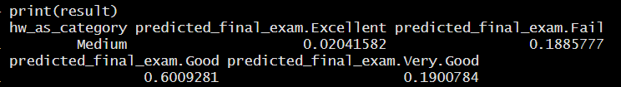
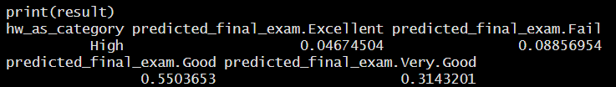

- All the above indicated a positive relationship between the extra activities and the final grade which are

Student Clustering
- K-means clustering and hierarchical clustering were used to identify student groups:
- High Performers
- Moderate Performers
- Low Performers
- The clustering aims to facilitate tailored educational interventions.
Here are the plot showing the clusters
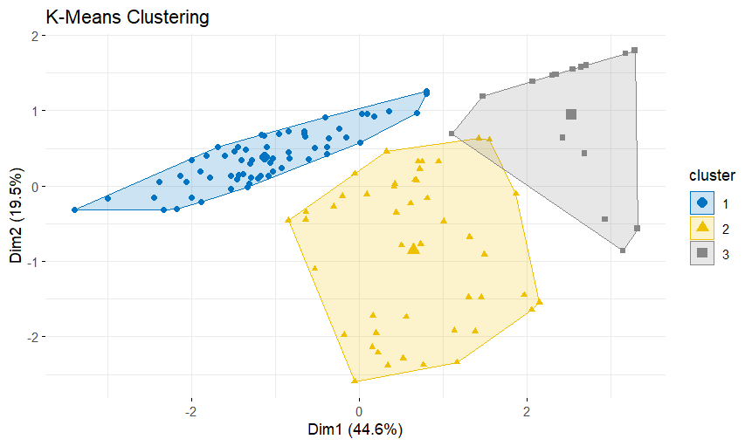
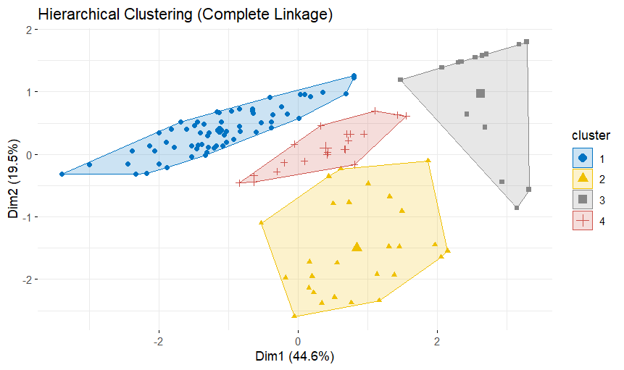
Results and Insights
- The analysis indicates a positive relationship between student grades and their activity scores, although the correlation is not very strong.
- The statistically significant correlation (p-value < 0.05) confirms that assignment performance influences final grades.
- Non-participation is a key indicator of poor performance.
- The clustering of students into performance groups can help in designing targeted interventions.

Conclusion and Recommendations
The presentation concludes by providing the following recommendations for improving student success.
- Regularly monitor student grades and participation.
- Provide extra support for low-performing students.
- Encourage engagement through optional activities.
- Provide targeted interventions for students at risk of failing
- Explore additional factors like attendance and study hours and habits for better predictions.

